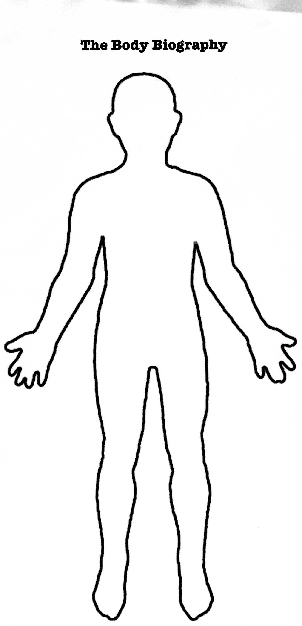
Body Biography Project

Group Members: _________________, __________________, ___________________, ________________

Points Possible Points Earned
Head: What does the character think about? | 10
Eyes: How does the character “see” the world? (Their perspective on the world around them) | 10
Mouth: What does the character say that reveals their personality to us? | 10
Neck: Who/what is a  “pain in the neck” for the character? (what annoys them or angers them?) | 10
Heart: What is the character’s motivation in life or in the text? | 10
Hands: What does the character “work on” in the text (physically or emotionally) | 10
Stomach: What does the character fear? | 10
Legs: Make a prediction about the future of this character. | 10
Achilles Heel: What is this character’s weakness? | 10
Citations: All quotes are correctly cited | 10
Total:

Body Biography Project

Director:
Monitor:
Recorder:
Reporter:

For each body part, answer the stated question AND include a quote that supports your answer. Make sure you correctly cite your quote (Act. Scene. Line)

Head: What does the
character think about?
Eyes: How does the character “see” the world? (Their perspective on the world around them)
Mouth: What does the character say that reveals their personality to us?

Neck: Who/what is a
“pain in the neck” for the character? (what annoys them)
Heart: What is the character’s motivation in life or in the text?
Hands: What does the character “work on” in the text (physically or emotionally)
Stomach: What does the character fear?

Legs: Make a prediction about the future of this character.

Achilles Heel: What is this character’s weakness?

