OKCPS Senior Capstone Project
-Service Learning-

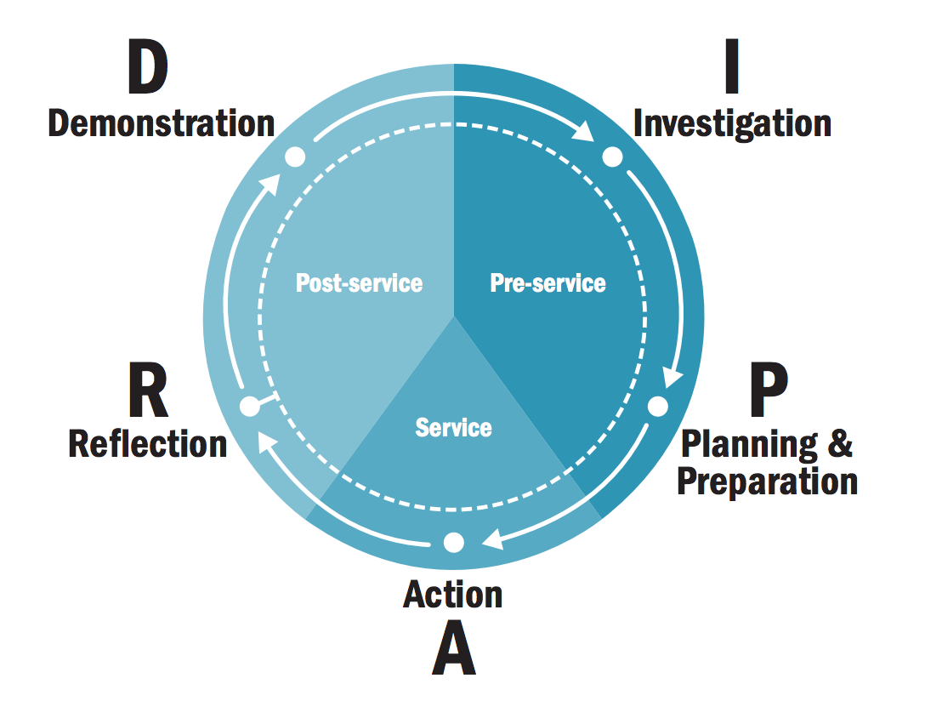
Investigation
Suggested timeframe : 7-10 days

What Students are Doing | What Teachers are Doing | Possible Assessments | Standards
- Self-reflection writing built around essential questions  - Discussions based upon essential question  - Fishbowl, Inner/Outer circles, or Socratic debate  - Collaborative Web inquiry  - Four Corners  - Disciplined Inquiry over areas of need in community, collaborative groups  - Reading literature to broaden prospective  - Mini-research paper  - Group presentations over areas of need | - Building essential question  - Write prompts for reflective writing  - Offering feedback & discussions over reflection  - Offering literature passages or texts that lead to inquiry and discussions  - Facilitate research  - Provide feedback research  - Facilitate revision and editing for research paper or presentations | - Daily / Participation activities  - Writing assessments  - Speaking & Listening evaluations  - Research aspects: credibility, thesis, textual evidence, support

Possible Essential Questions:
What are the needs/problems in my various communities?
What am I able to do to impact or make a difference to address my community’s needs?
How can participation in the arts improve a person’s life?
In what ways can community involvement benefit an individual?
How can continuous reflection or self-evaluation help an individual or group grow?

Planning and Preparation
Suggested timeframe : 4-6 days

What Students are Doing | What Teachers are Doing | Possible Assessments | Standards
- Presentations over possible project ideas  - Evaluating possible ideas and voting on a project as a class  - Reaching out to community partners  - Gathering information  - Organizing  - Predicting obstacles  - Setting goals and discussing objectives  - Reading literature to broaden perspectives  - Reading nonfiction to find support  - Annotating texts | - Supporting presentations with framework or rubrics  - Guiding evaluation of possible projects  - Establishing relationship with possible community partners  - Offering options for information, literature, texts | - Oral presentations  - Supporting information, evaluate relevance  - Clarity and mechanics of written objectives/goals  - Score and offer feedback on literature/text responses

Action
Suggested timeframe : 1-5 days

What Students are Doing | What Teachers are Doing | Possible Assessments | Standards
- Set up service project (can be on campus or off campus)  - Participate in service (this can be a one day event or several days of service)  - Interact with those who are receiving the service  - Understand reciprocal relationship of those giving service and those receiving  - Daily reflection or self-evaluation  - Close down service project | - Organize student tasks or student leadership groups  - Record attendance and participation  - Supervise service | - Sample Service rubric  http://blogs.ksbe.edu/shkahue/files/2011/01/Essential-questions-and-rubric.pdf

Reflection
Suggested timeframe : 2-4 days

What Students are Doing | What Teachers are Doing | Possible Assessments | Standards
- Narrative writing over experience  - Individual question authoring  - Group reflections through strategies like: T-charts, 3-2-1, Sticky Bars, 4 corners, Agreement circles, etc…  - Small reflective writing  - Developing inferences or drawing conclusions  - Persuasive writing using Claim-Evidence-Reasoning (C.E.R)  - Debates  - S.W.O.T (strengths, weaknesses, obstacles, threats)  - Compare/Contrast using published texts about service projects around the nation | - Distributing writing rubrics to guide writing process  - Facilitating reflective discussions  - Scaffolding persuasive/argumentative writing through small activities  - Finding and providing articles/texts of other service projects for comparison | - Writing evaluation for different genres of writing  - C.E.R rubric for claim, evidence, reasoning

Demonstration
Suggested timeframe : 7-15 days

What Students are Doing | What Teachers are Doing | Possible Assessments | Standards
- Final research paper  - Mini-research paper  - Class Presentations  - Presentations for community: parents, admin, community members | - Creating and demonstrating writing rubrics  - Offering credible resources for research or practice for finding credible resources  - Scaffolding the research and writing process  - Offer time to explore library databases for research  - Giving resources and allowing practice for MLA style  - Develop revision conferences and feedback for draft | - Writing & research evaluations with feedback  - Speaking and Listening evaluation for presentations

Resources for later:
Rubric- http://blogs.ksbe.edu/shkahue/files/2011/01/Essential-questions-and-rubric.pdf

