TIMED VISUAL DOCUMENT ANALYSIS FORM

NAME: _________________________ PERIOD: _______ DATE: ____________

Directions: Using the document provided, attempt to analyze it with no more than one sentence for each of the items. Write your answers below.

Harappan seals of the Indus Valley, 2nd millennium BCE

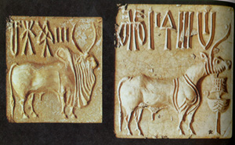

- Overview:

- Parts:

- Title:

- Interrelationships:

Conclusion

